**RESULTS**

**1. Demographic data analysis:**

**i)Age distribution:** The Patient’s age ranges from 20 to 95. The lowest age encountered with coronary artery disease being 24 and highest age being 95 in this study.

Around 63% of the participants with CAD have an age range between 46 and 65.

**ii)Gender distribution pattern:**

In this study, males are predominantly affected by coronary artery disease than females and the percentage for males being 56% and females being 44%.

**iii) Socio-economic status**

The Socio-economic status of the participants has been analyzed and inferred with *“The Modified Kuppuswamy Scale”* as reference. Participants with “Upper Middle” class are predominantly affected by CAD with a distribution of 81%.

**2.Co-morbidity distribution pattern:**

The participants with hypertension and diabetes are the most affected with CAD than others. The comorbidity distribution is illustrated as below:

**3.Assessment of prescription pattern as per WHO/INRUD drug use indicators:**

|  |  |  |  |
| --- | --- | --- | --- |
| **S. No** | **Drug use indicators** | **Result** | **WHO Standard** |
| **1** | Average number of drugs per prescription | 8.57 | 1.6 - 1.8 |
| **2** | Percentage of encounters with Antibiotics prescribed | 22.51% | 20.0% - 26.8% |
| **3** | Percentage of drugs prescribed by generic name | 39.31% | 100% |
| **4** | Percentage of encounters with Injections prescribed | 15.59% | 13.4% - 24.1% |
| **5** | Percentage of drugs prescribed from the National Essential drug list | 85.71% | 100% |
| **6** | Percentage of drugs prescribed In Fixed dose combination | 10.59% |  |
| **7** | Average number of Antibiotics per prescription | 0.28 |  |
| **8** | Percentage of drugs dispensed from hospital drug store at free of cost | 69.79% |  |
| **9** | Percentage of drugs purchased by patients at cost | 30.21% |  |

**4.ATC/DDD Classification of drugs in CAD:**

|  |  |  |  |  |
| --- | --- | --- | --- | --- |
| **DRUG** | **ATC** | **PDD** | **DDD** | **PDD/DDD** |
| Isosorbide di nitrate | C01DA08 | 23.72 | 60mg O | 0.395 |
| Isosorbide mono nitrate | CO1DA14 | 20 | 40mg O | 0.5 |
| Glyceryl tri nitrate | CO1DA02 | 5.525 | 5mg O | 1.10 |
| Ranolazine | C01EB18 | 1000 | 1500mg O | 0.66 |
| Trimetazidine | C01EB15 | 45 | 40mg O | 1.125 |
| Aspirin | B01AC06 | 1 tablet | 1tablet O | 1 |
| Clopidogrel | B01AC04 | 75 | 75mg O | 1 |
| Heparin | B01AB01 | 15000 | 10000 U | 1.5 |
| Enoxaparin | B01AB05 | 8000 | 2000 U | 4 |
| Warfarin | B01AA03 | 5 | 7.5mg O | 0.66 |
| Enalapril | C09AA02 | 6.17 | 10mg O | 0.61 |
| Metoprolol (O) | C07AB02 | 16.761 | 150 mg O | 0.11 |
| Amlodipine | C08CA01 | 8.333 | 5mg O | 1.66 |
| Atenolol | C07AB03 | 45.83 | 75mg O | 0.611 |
| Telmisartan | C09CA07 | 53.33 | 40mg O | 1.33 |
| Atorvastatin | C10AA05 | 24.96 | 10mg O | 2.496 |
| Rosuvastatin | C10AA07 | 20 | 10mg O | 2 |
| Fenofibrate | C10AB05 | 145 | 200mg O | 0.725 |
| Furosemide (0) | C03CA01 | 39.09 | 40mg O | 0.977 |
| Furosemide (P) | C03CA01 | 54 | 40mg P | 1.35 |
| Spironolactone | C03DA01 | 55 | 75mg O | 0.733 |
| Torsemide | C03CA04 | 11 | 15mg O | 0.733 |
| Carvedilol | C07AG02 | 5.0781 | |  |  |  | | --- | --- | --- | | 37.5 mg O |  |  | | 0.13 |
| Digoxin (0) | C01AA05 | 0.23 | 0.25mg O | 0.92 |
| Nicorandil | C01DX16 | 7.5 | 40mg O | 0.18 |
| Trimetazidine | C01EB15 | 40 | 40mg O | 1 |
| Metformin | A10BA02 | 1044 | 2000 mg | 0.522 |
| Glimepiride | A10BA12 | 2.1764 | 2 mg O | 1.08 |

**5.Observed utilization of anti-platelets in CAD:**

Among the 151 patients diagnosed with CAD, 76 of them were prescribed both Aspirin and Clopidogrel which is 50% of the total encounters. Only Aspirin was prescribed to 36% and Clopidogrel alone was prescribed to 10% of the total encounters.

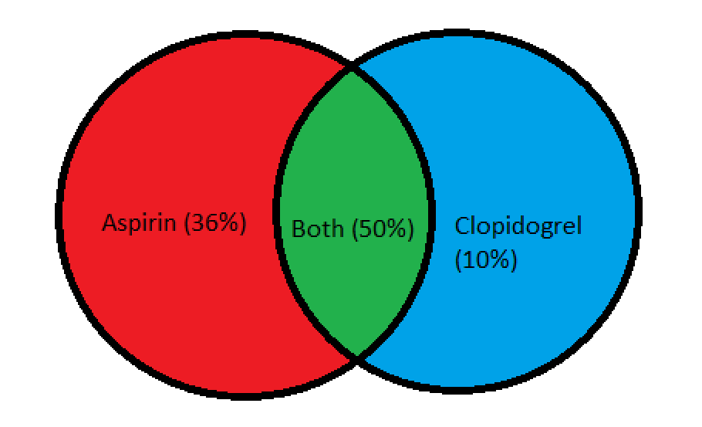

**6.Observed utilization of anti-coagulants in CAD:**

Among the anti-coagulants used, unfractionated Heparin and Enoxaparin are the most used anticoagulants. Out of 151 encounters, 22 (15%) of them were prescribed Heparin and another 22 (15%) of them were prescribed Enoxaparin.

**7.Observed utilization of hypolipidemic drugs in CAD:**

Among the 151 encounters, Atorvastatin was the most prescribed hypolipidemic drug accounting to 88% of total prescriptions. The second highest prescribed drug is Rosuvastatin accounting to 4%.

**8.Observed utilization of Anti-Anginal drugs in CAD:**

Iso-sorbide Dinitrate and Nitroglycerine are the most commonly prescribed anti-anginal drugs in this study. Out of 151 encounters, 51 (33%) of them were prescribed Iso-sorbide Dinitrate and another 8 (5%) of them were prescribed Nitroglycerine.

**9.Observed utilization of Anti-hypertensive drugs in CAD:**

Among the 151 encounters, Enalapril was the most prescribed Anti-hypertensive drug accounting to 53% of total prescriptions. The second highest prescribed drug is Metoprolol accounting to 29%. This is followed by Amlodipine (10%), Telmisartan (6%) and Atenolol (4%).

**10.Observed utilization of Anti-diabetic drugs in CAD:**

Among the 151 encounters, Metformin was the most prescribed Anti-Diabetic drug accounting to 31% of total prescriptions. The second highest prescribed drug is Inj.Actrapid accounting to 16% followed by Glimepiride accounting to 12%.

**11.Observed utilization of Antibiotic drugs in CAD:**

Only 22% of the patients were prescribed antibiotics.

Out of which, Ceftriaxone is the most commonly prescribe antibiotic accounting to 14% of the total encounters

**12.Observed utilization of diuretics in CAD:**

Of all the diuretics prescribed, Furosemide has been prescribed the most – 14.5% via Tablet and 13.2% via Injection. This is followed by Spironolactone (6%) and Torsemide (2%) of all the encounters.

**13.Observed utilization of heart failure drugs in CAD:**

Carvedilol and Digoxin were prescribed equally (5%) as heart failure drugs. Nicorandil (4%) and Ivabradine (2%) were the other drugs prescribed.

**14.Observed utilization of other drugs in CAD:**

Most commonly used other drugs in CAD being vitamin B complex with calcium or vitamin C (46%), Ranitidine with antacid syrup(44%).